Directions from Departure Level Curbside
Starting Point: Arrivals Level Curbside (2000 Post Rd, Warwick, RI 02886)
Destination: Cell Phone Lot (2200 Post Rd, Warwick, RI 02886)

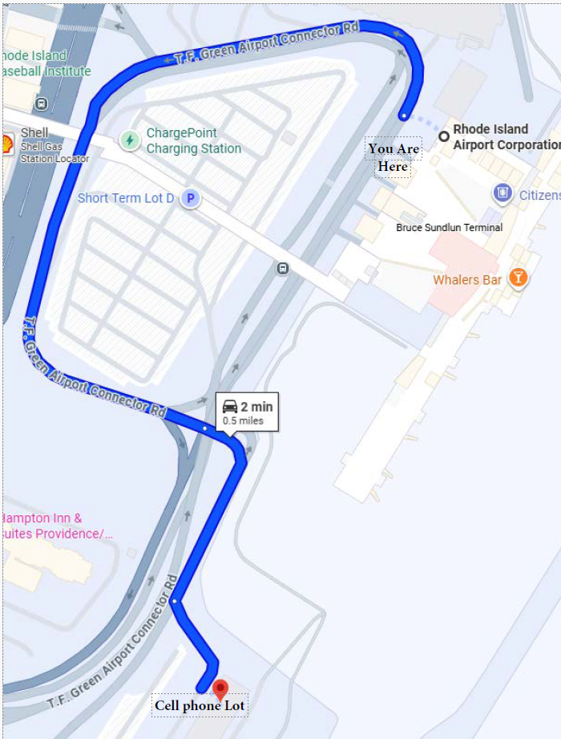
Step-by-step Directions:
📍 Start: Rhode Island Airport Corporation (2000 Post Rd, Warwick, RI 02886)
- Head northeast on T.F. Green Airport Connector Rd for 0.4 miles.
- Continue straight for 466 feet.
- Turn left – the Cell Phone Lot will be on your left after about 230 feet.
📌 Destination: Cell Phone Lot (2200 Post Rd, Warwick, RI 02886)
Navigation Tip:
Scan QR Code below for turn-by-turn for navigation.


